

Virtualization Technologies

CMPE 283 Spring 2014

Nachammai Chinnanchetty

SJSU ID: 006900179

March 30 2014

TABLE OF CONTENTS

Introduction …………………………………………………………… 3

Background …………………………………………………………… 3

Requirements (Functional and Non-Functional) ……………………… 4

Design and Architecture ………………………………………………. 5

Implementation and testing results ………………………………….. 7

Discussion …………………………………………………………… 15

Conclusion ……………………………………………………………. 17

References …………………………………………………………….. 18

Introduction

The objective of this project is to design a availability manager using EXSi’s Java API. A disaster recovery system monitors the health of the virtual machines running at a site. At any state, if that site fails, the system determines the site/host that is to be used to restart each failed virtual machine. The objective in a simpler setup is to build the availability manager that monitors the liveliness of the VMs running on any of the hosts and restarts the failed VMs by caching the previous versions of the VMs.

The goal of this project is to gain experience with hypervisors and management servers, to explore the capabilities offered by these components and their APIs, to apply the concepts discussed in the course to a real-world problem, and to learn about the issues arising from interoperability.

In real world, IT organizations needs to ensure business continuity. Many organizations use virtual environment to launch their applications. In such scenario if a server fails or goes out of the network, the application will become unavailable leading non-dependable product. Thus, server virtualization introduces new challenges in implementing disaster recovery policies. The traditional backup process doesn’t work well for virtual server backup. A virtual environment uses shared resources, network and storage and seems to be a cost-effective alternative for underutilized servers. Hence, the virtualization industry focusses on real time replication of data to a new location. Virtualization can help with speeding up recovery time, because it is easier to start up a virtual machine on a hypervisor such as VMware's ESX than rebuild a physical server from scratch.This strategy dramatically reduce the cost, time, complexity and unpredictability of traditional IT disaster recovery management solutions by taking advantage of the inherent flexibility, agility and efficiencies of a virtualization-enabled data center.

Background

Disaster recovery is the process of planning that protects and recovers the organization’s resources in the event of disaster. It is a business continuity plan that assures availability of all resources included in the infrastructure. The goal of a disaster recovery is to resume normal computing capabilities in as little time as possible.

With respect to IT organizations, virtual environment is becoming more common these days. Most of the applications developed are hosted on virtual servers. A typical data center has thousands of virtual servers. Every virtual server has hypervisor installed on them to support software virtualization. Using this setup, we can in turn create hundreds of virtual machines on top of them forming a nested virtual environment. If there is a network issue or some server problem in this complex structure of servers, the virtual machine may fail to respond of crash. This causes applications which are running on those virtual machine to fail and become unresponsive. To overcome the complete failure, we should be able to make these VMs and applications hosted in them come alive with in a short downtime.

### This project aims at building disaster recovery for a Virtual Machine in a data center which assures to make a virtual machine available in the alternate host even after its failure in the earlier host. This helps in keeping the entire data center up and running all the time.

Requirements

Functional Requirements:

1. The typical architecture required to implement this project is an virtual machine environment set with 2 hosts and more than 1 virtual machines on those hosts.
2. Virtual machine should respond to the ping requests. For this required, I had to enable vmtools in all virtual machine present in every host.
3. Take Snapshots for every 10 minutes.
4. Detect any VM failure and migrate the corresponding VM to another host using the snapshot
5. On taking periodic snapshots of the VM, keep the latest one on the system and remove all the others.
6. Check the availability of the host where you are going to migrate the VM.
7. Able to perform cold migration.
8. Clone from the snapshot of the VM.
9. Migrate that cloned VM to another host that is available.
10. When the user switches off the VM there should be alarm triggered. In this case the recovery of the VM should not be done as it is powered off by user.
11. Before recovering any VM, should check if the VM is powered off by the user.

Non-Functional requirements:

1. VM failure is demonstrated manually by disconnecting network interface card of the VM.
2. System should not stop abruptly at any point because we will not be able to monitor the servers and there is a chance we lose our disaster recovery feature and availability.
3. System should able to monitor newly added VMs and get the statistics of any VM present in the setup.

Design

Architecture:

One new vCenter was created in CIR2. The IP 130.65.132.210, domain name and other network properties were set for the new vCenter. If there was only one vHost present in the setup, another vHost was created from templates. This vHost contains ESXi software installed on it. In the virtual server thats acts as a vCenter, I added all the vHosts. Every vHost had virtual machines connected to it. The virtual machine was created and installed with Ubuntu operating system. Thus, the vCenter is responsible for managing vHosts and VMs within them.

Now, when I log into vCenter server using vSphere client, I can find the two vHosts on this vCenter server. Now this vCenter will monitor the two hosts. One of these vHosts will be used as a backup vHost and virtual machines will be migrated on this at the time of failure.

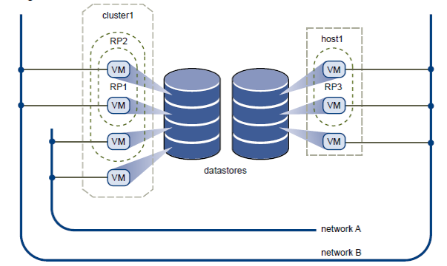

Fig 1: Virtual Datacenter Architecture

The above figure describes the architecture of Disaster Recovery. On the left, there is a cluster holding two resource pools having multiple VM’s connected to different networks. On the right, there is a host having multiple VM’s within a single resource pool connected to same network.

This architecture comprises of various components like multiple VMs hosted on vHosts and a vCenter which acts like a server in the data center. There is a NFS datastore that stores all VMs.

Components:

Cluster: It is a group of servers sharing the resource pools, same network and storage arrays.

vCenter Server: This is a windows 2008 server with VMware vCenter server tool installed on it. The ESXi is installed as bare metal hypervisor type 1. This component is used to manage the vHost servers that comprises of VMs. It is centralized platform for managing the virtual infrastructure.

vHost: This component is a virtual machine which has ESXi 5.0 as its guest OS. This vHost will host the actual virtual machines which will run the applications.

Virtual Machine: The VM denotes the actual virtual machine PAGE 6 which will host the application.

Datastore: Datastores are a data storages which are connected to the vHosts and provides space for storing VMs.

Datacenter: Data center is a collective term that includes all the vHosts, data stores connected to it and VMs running in vHosts. It is a complete architecture of a system which is required to run an application on a virtual machine.

Key Workflows:

1. Get the statistics of any VM present in the datacenter.
2. Ping all the VMs available on the datacenter and look if any of these are not reachable.
3. If not reachable, then check if it is powered off by the user.
4. If powered off, then create an alarm on that VM saying this VM is not failed and that is manually powered off by the user.
5. If the VM is reachable take snapshots and refresh them for every 20 minutes.
6. If a VM are not reachable and it is not powered off, it implies that the VM has failed.
7. In case of VM failure, clone that VM from the latest snapshot available.
8. In case all VMs associated with a vHost is failed, check if vHost is alive.
9. If vHost is not reachable then migrate all VM on that host to secondary vHost.
10. Turn on VMs after migration if they were not powered off by user.

Implementation

Tools and languages:

For developing this system, I used following tools:

JDK 1.7.0: System is developed using Java 7. So I installed JDK 1.7 on the system to develop the application.

Eclipse IDE: Java development is done using Eclipse IDE - Kepler Release 1.

VI API: The VI Java APIs are provided by VMware. The Virtual Infrastructure APIs gives developer the developer an opportunity to communicate to the VMware resources and develop the custom application to manage virtual resources in datacenter.

VMware vSphere: This is a VMware tool to communicate to the virtual machine. By using vSphere client I connected to the 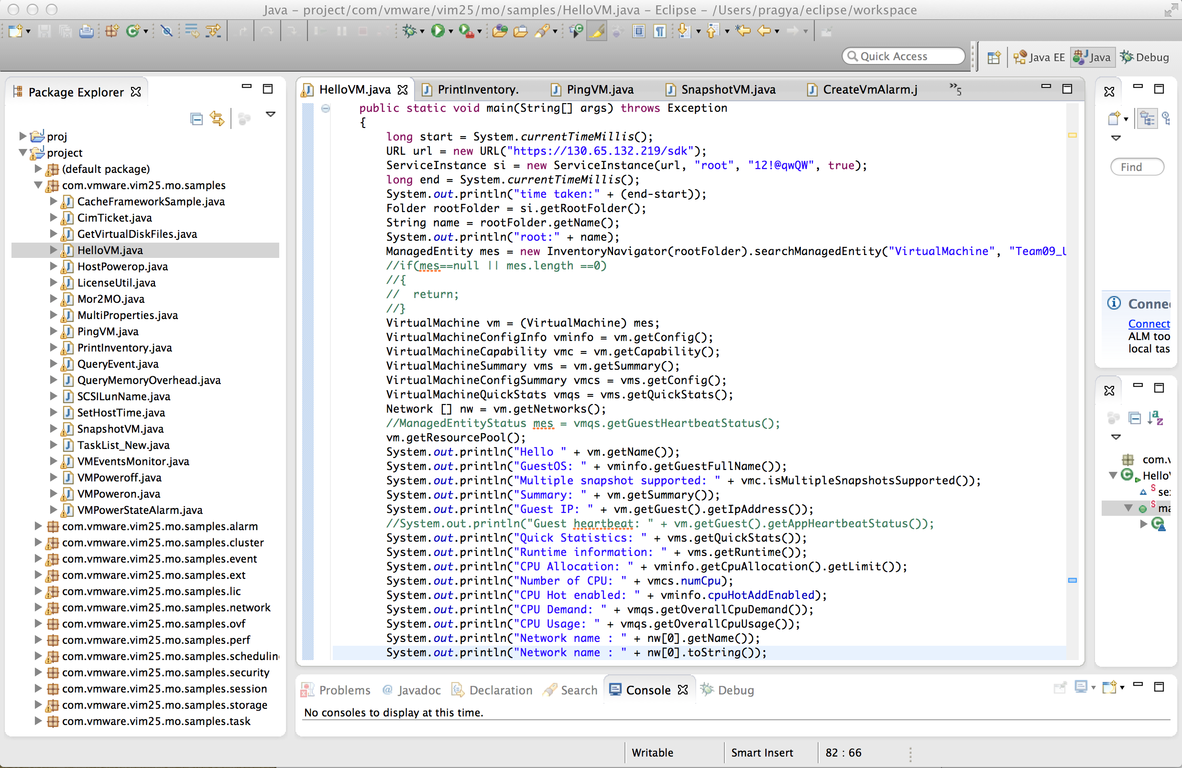vCenter, vHost to manage and monitor the virtual machines.

**Approaches:**

1. **Gather statistics (such as CPU, I/O, network etc) for a VM**

The CPU, network configuration and input/output statistics of a VM is gathered using different APIs like VirtualMachineConfigInfo, VirtualMachineCapability, VirtualMachineSummary, VirtualMachineConfigSummary, VirtualMachineQuickStats, Network. I captured the statistics of VM “Team09_Ubuntu_Nachu”. This can be done for all VMs in a datacenter or for particular VM of user choice. The Fig 2 snapshot gives an idea of the APIs and their usage. The Fig 3 captures the corresponding statistics output of a VM.

Fig 2: Statistics of a VM

Fig 3: Output Statistics of a VM

1. Monitoring VMs using ping

Every VM needs to be monitored regularly using heartbeats. If a VM doesn’t respond the applications hosted on it may become unreachable. So, checking the VM for it aliveness is carried by process p2. I also wanted to check the status of the host regularly. Process p1 polled the status of hosts. As these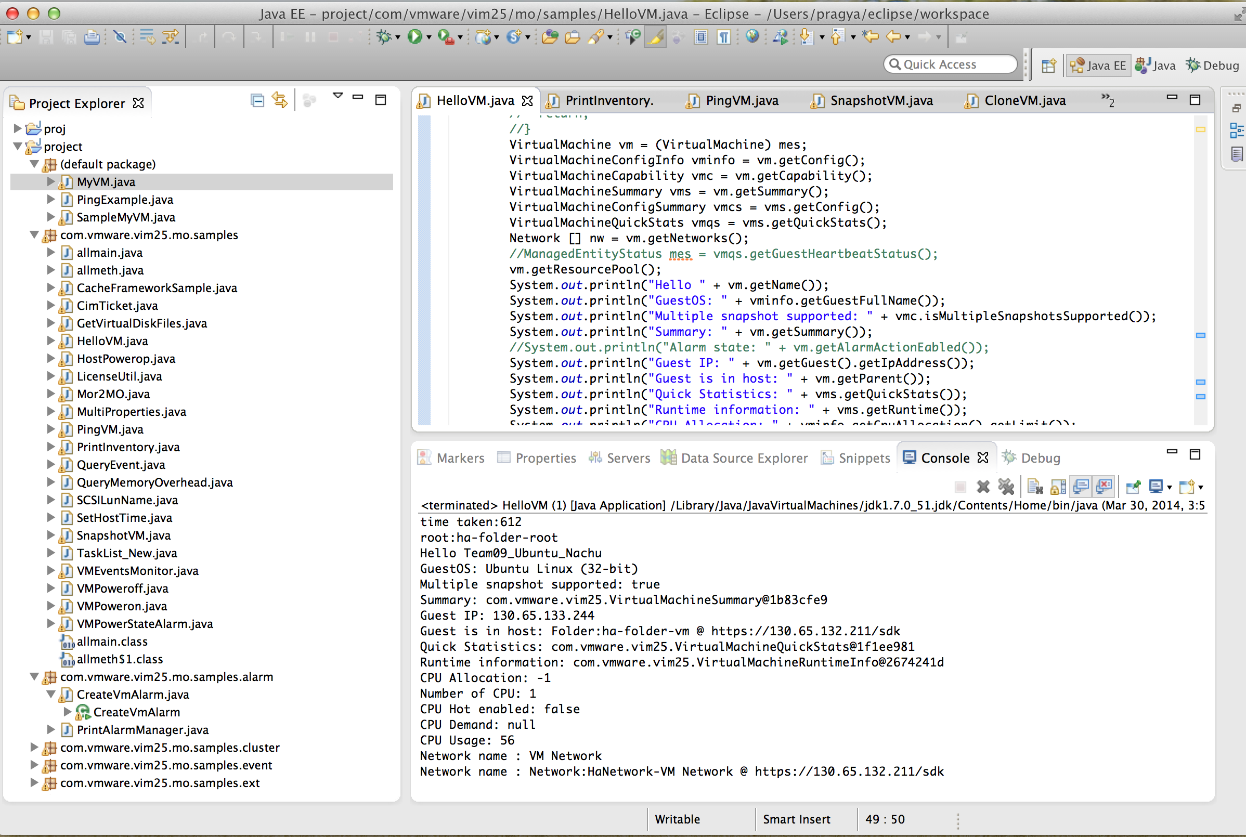 process need to be called every few minutes, I ran a thread for ping. The Fig 4 gives a snapshot of the implementation of ping in hosts and VMs using APIs. The Fig 5 captures the corresponding ping output of hosts and VMs.

Process p1 = java.lang.Runtime.getRuntime().exec("ping -c 1 "+hosts[i].getName());

Process p2 = java.lang.Runtime.getRuntime().exec("ping -c 1 "+vm.getGuest().getIpAddress());

Fig 4: Monitoring hosts and VMs using ping

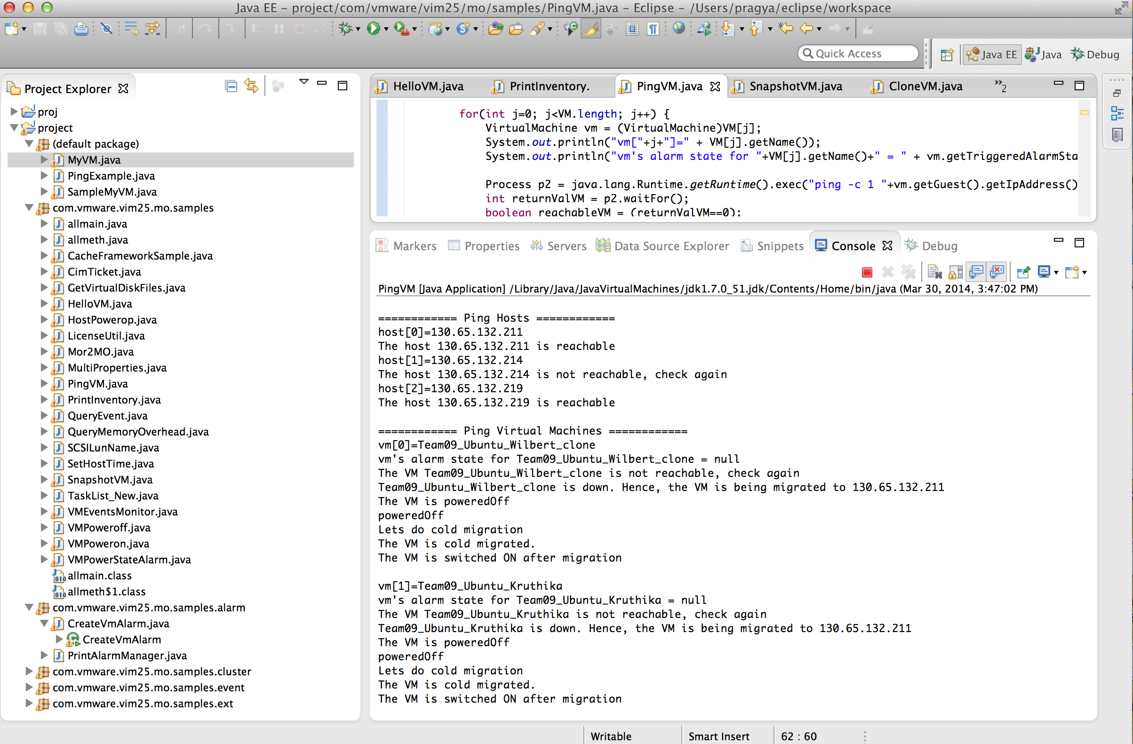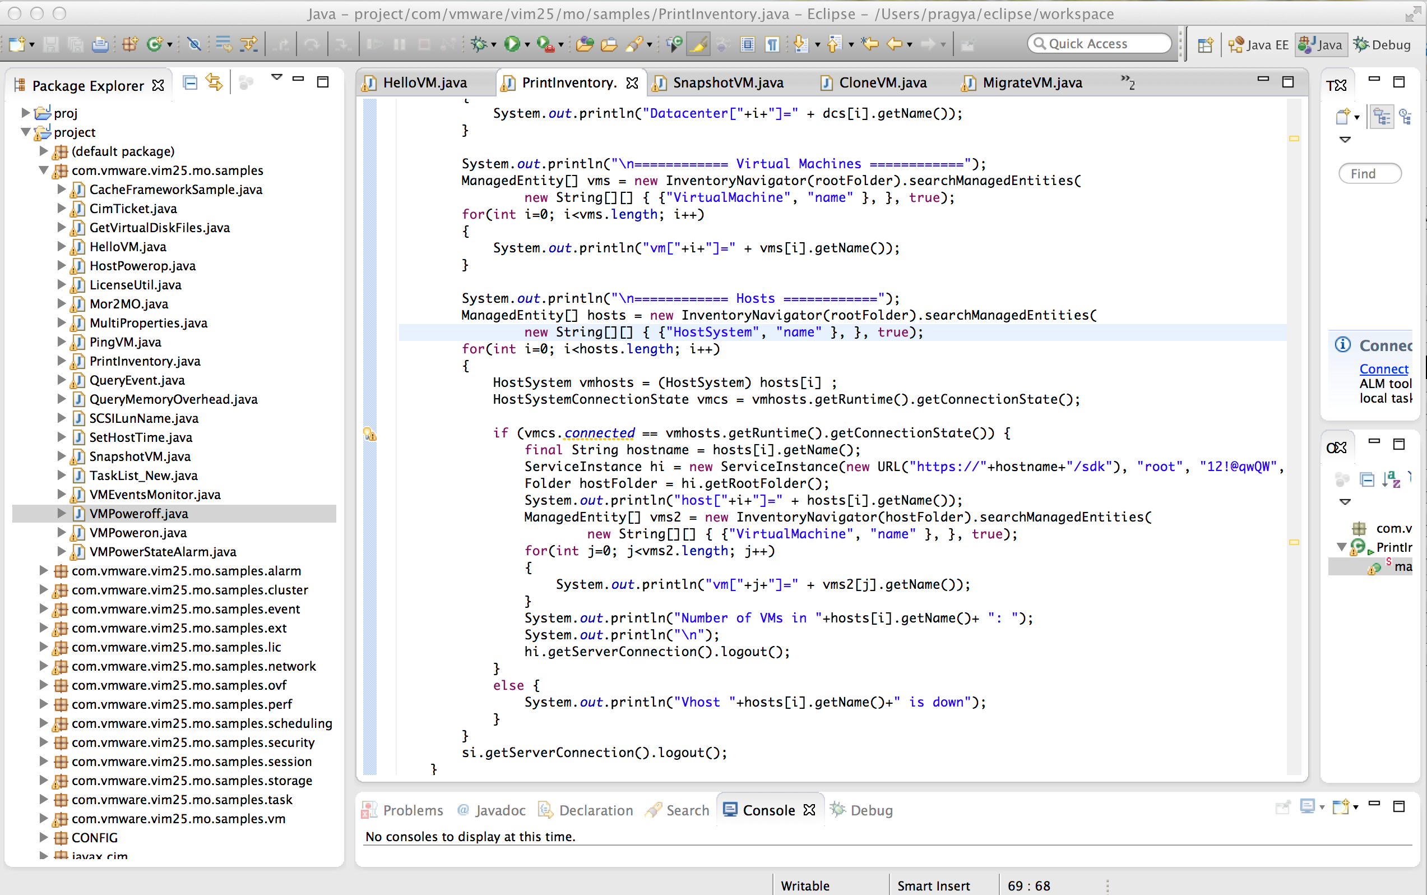

Fig 5: Output Pinging of hosts and VMs

1. Snapshot of VM every 20 mins

The snapshots are point in time image of the virtual machines that includes disk, memory device state at the time the snapshot was taken. If the VM is reachable and it responds to the ping the snapshots are created as a backup so that it can be used in future. A snap shot created is refreshed after every 20 mins in order to keep the snapshot up-to-date. Following is the code snippet for creating, deleting and re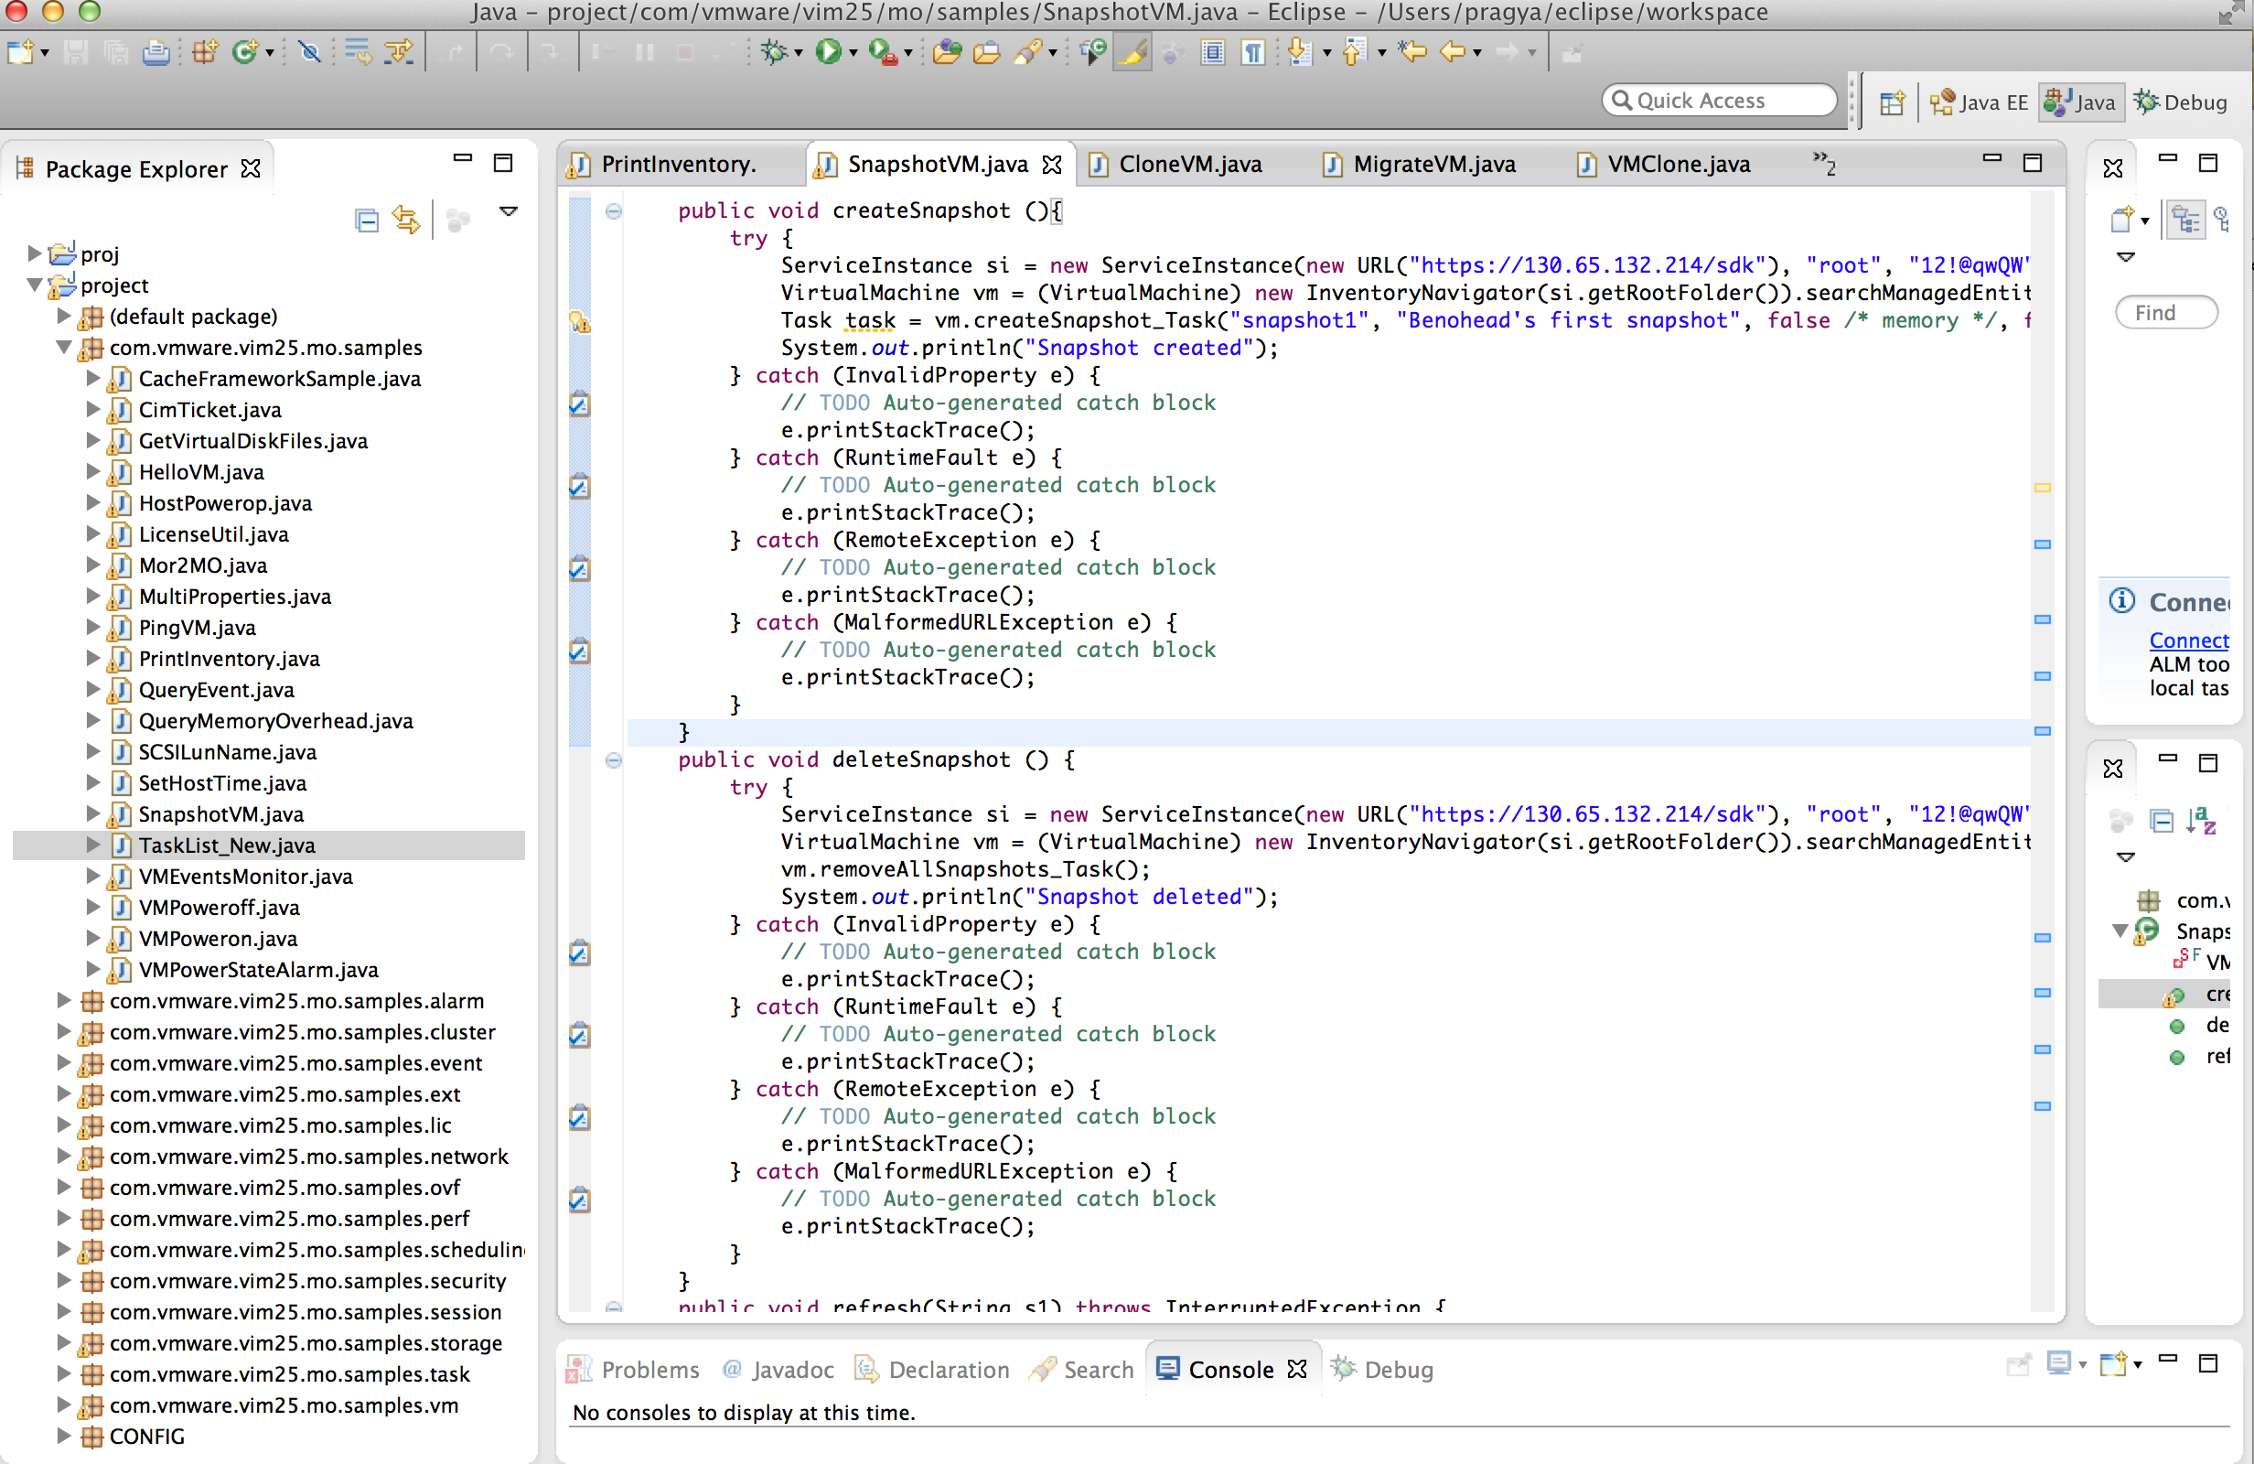freshing a VM. I have created a snapshot for VM “Team09_Ubuntu_ Kruthika”Fig 6 has the code for refreshing snapshot for every 20 minutes and Fig 7 shows the output of running the code.

sexecs.scheduleAtFixedRate(new Runnable() {

public void run() {

SnapshotVM vmsp = new SnapshotVM();

try {

vmsp.refresh("130.65.132.214");

}

catch (InterruptedException e) {

e.printStackTrace();

}

}

}, 0, 50, TimeUnit.SECONDS);

Fig 6: Refreshing Snapshot of a VM

Fig 7: Output for Snapshot of a VM

1. Cloning of VM

Cloning of VM is done in case of VM failure. A clone VM is created from the latest snapshot that was taken when the VM was reachable. In order to keep the snapshots refreshing - 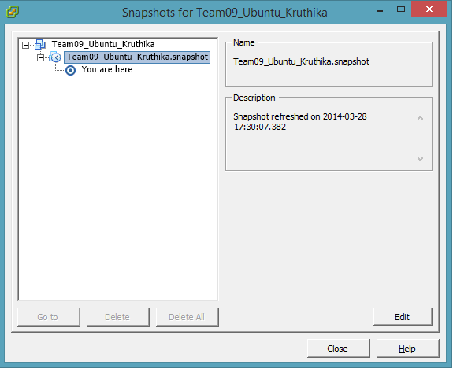deleting the old snapshot and creating a new snapshot, I had a thread for snapshot of VMs running for every 20 minutes. I have created a clone for VM “Team09_Ubuntu_Nachu”. Fig 8 has the code for creating the snapshot of a VM and Fig 9 shows the output of running the code.

Fig 8: Cloning of a VM

Fig 9: Output for Cloning of a VM

1. Migrating VM

Migrating a VM to another vHost happens in case the vHost in which the VM resides becomes unresponsive. In such cases the VM is cold migrated to another vHost that is alive. I tested with V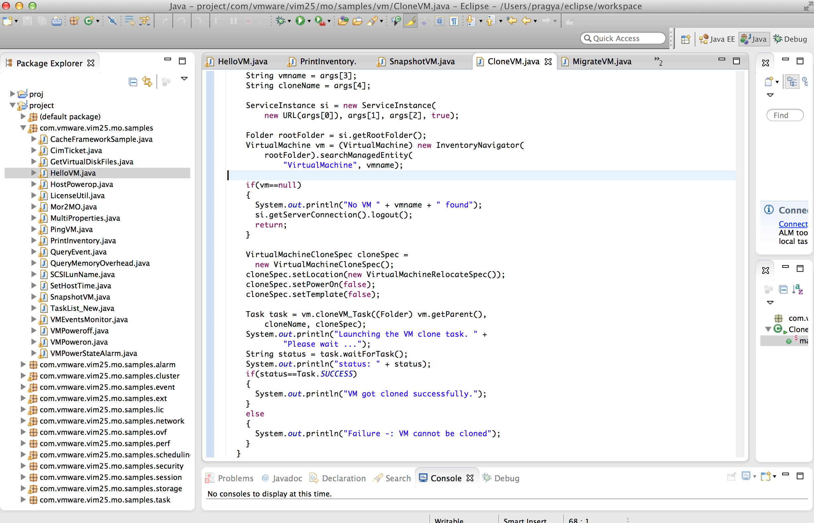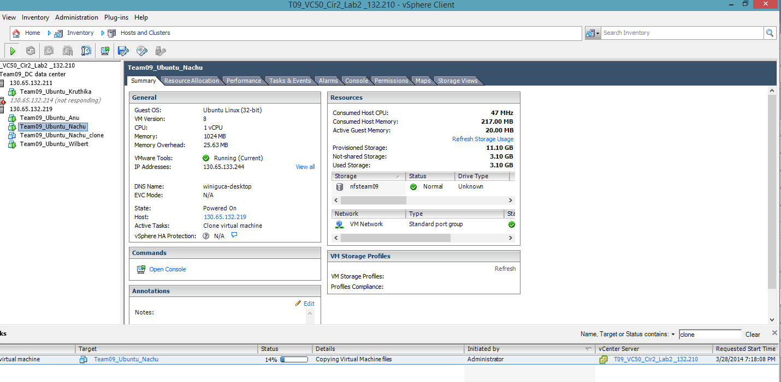M “Team09_Ubuntu_Nachu”. This VM was running in 130.65.132.211 vHost and when the vHost was made down, the VM got migrated to the first available vHost and it was powered on. Fig 10 has the code for migrating a VM and Fig 11 shows the output after migrating.

String vmname = "Team09_Ubuntu_Nachu";

String newHostName = “130.65.132.219"; //for individual class testing purposes

ServiceInstance si = new ServiceInstance (

new URL("https://130.65.132.210/sdk"), "administrator", "12!@qwQW", true);

Folder rootFolder = si.getRootFolder();

VirtualMachine vm = (VirtualMachine) new InventoryNavigator(

rootFolder).searchManagedEntity(

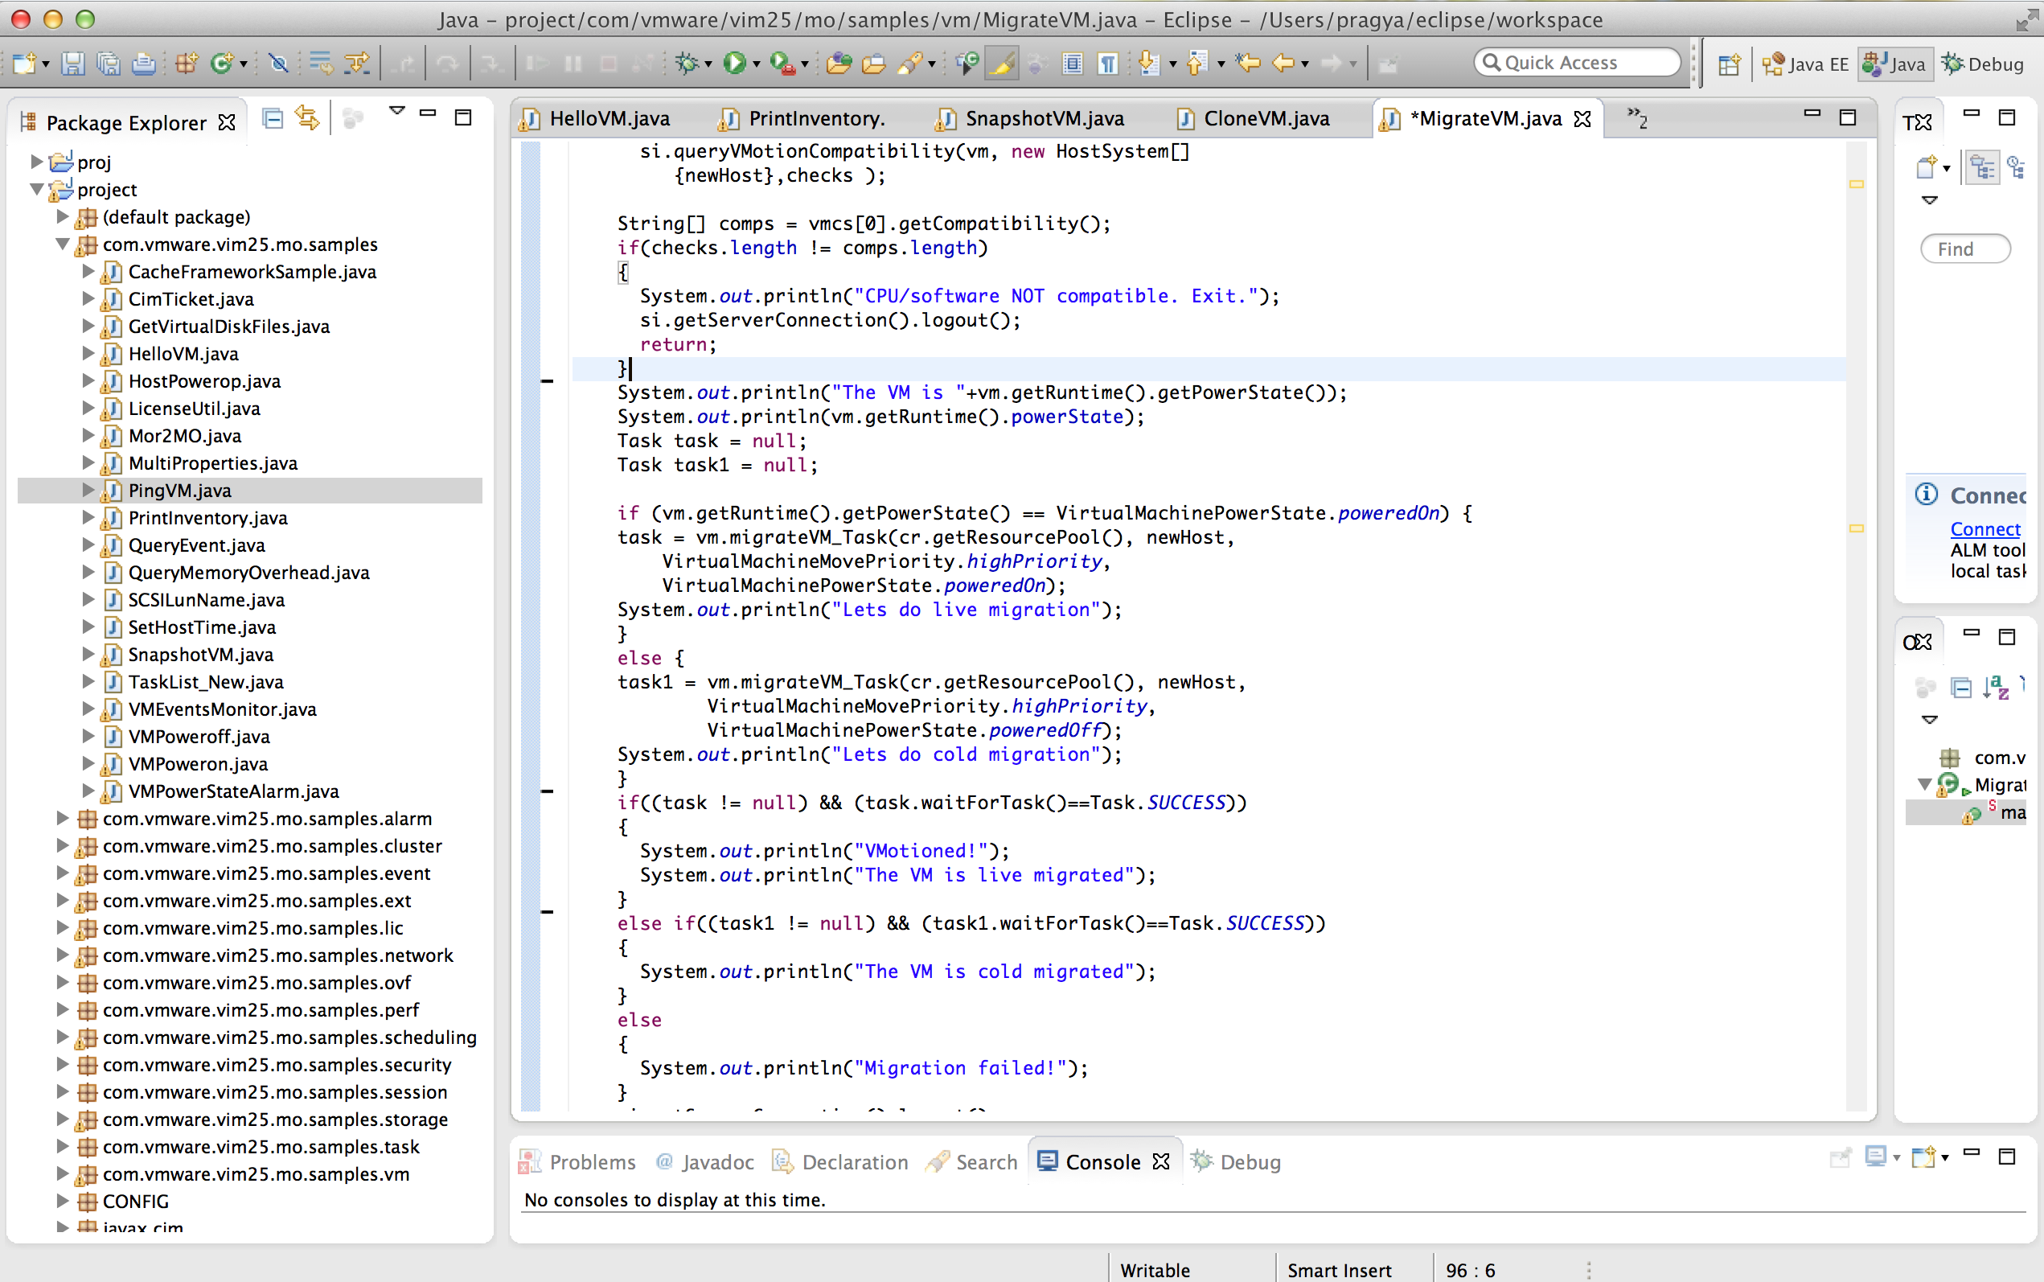 "VirtualMachine", vmname);

ManagedEntity[] hosts = new InventoryNavigator(rootFolder).searchManagedEntities(

new String[][] { {"HostSystem", "name" }, }, true);

HostSystem newHost = (HostSystem) new InventoryNavigator(

rootFolder).searchManagedEntity(

"HostSystem", newHostName);

ComputeResource cr = (ComputeResource) newHost.getParent();

Fig 10: Migrating of a VM

Fig 11: Output for Migrating a VM

1. Alarm Trigger on user power off of a VM

If a VM is powered off by a user, it would no longer be reachable. This scenario should not be considered as failure. So, to identify such user generated scenarios, I created an alarm in all VMs in the datacenter. Whenever a new VM is created, a new a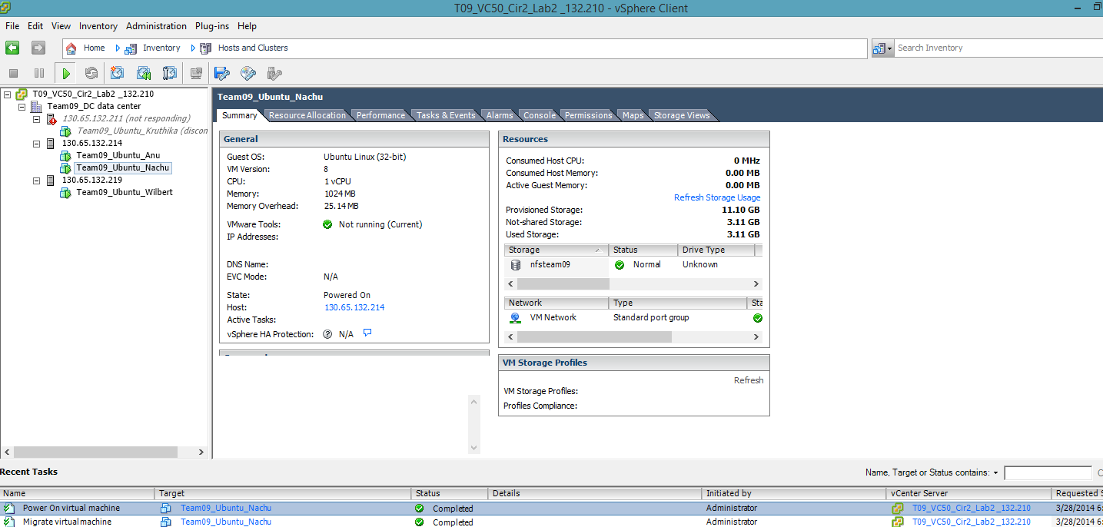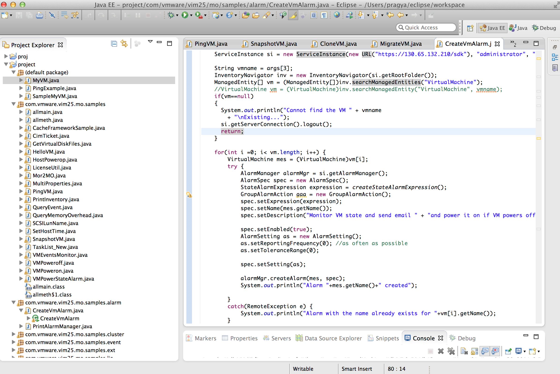larm would be generated in the name of the VM. If the user powers off any VM, the alarm will be triggered. If the alarm is triggered, that particular VM will not be migrated even though its heartbeat would be unreachable. Fig 12 has the code for creating the snapshot of a VM and Fig 13 shows the output of running the code.

Fig 12: Creating an alarm in VM

Fig 13: Output for creating an alarm in a VM

Discussion

I would like to discuss the algorithm of my approach and certain additional feature implementation in this section. Initially, in the printVM, I was able to see the Datacenter, all VMs and all Hosts present in the datacenter. However, I wanted to know all the VMs present inside a particular vHost. So, I added a section of the host folder to get all VMs present in the vHost. Also, I got an array of alive hosts after pinging the vHosts so that if a VM needs to be migrated, I made the destination to 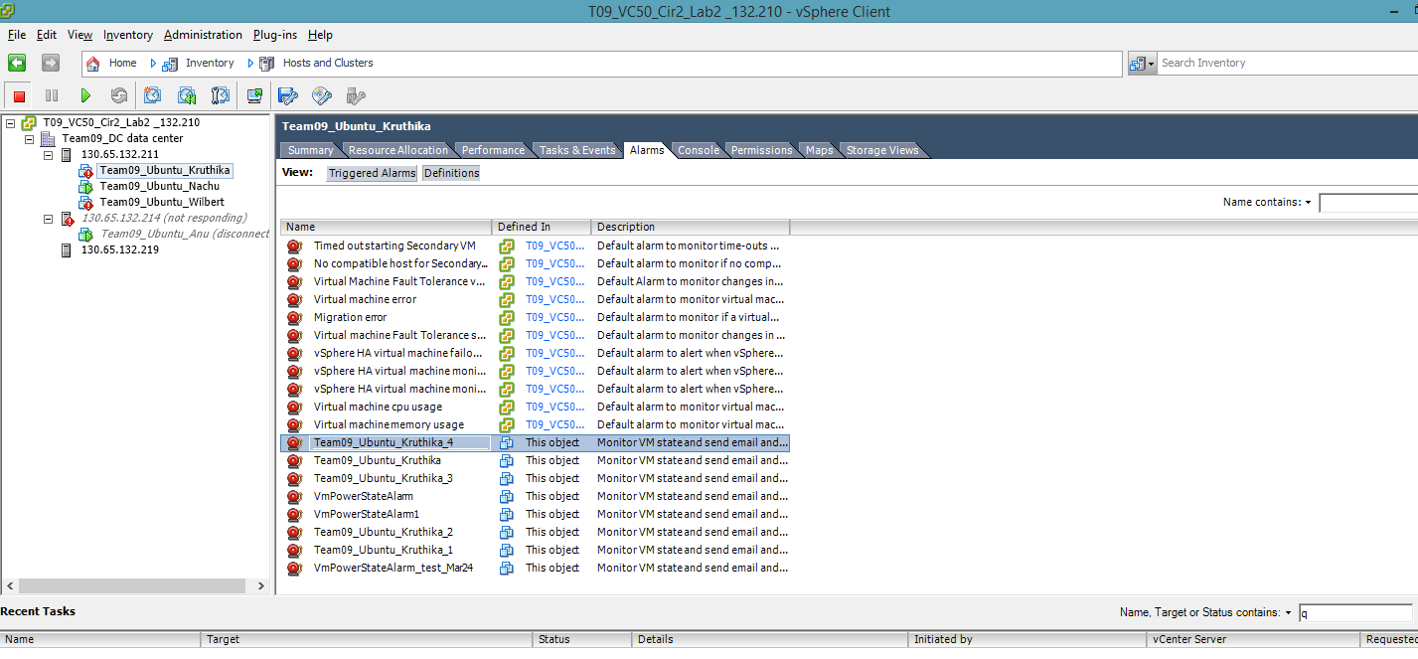be the first available vHost in the alive array of vHosts. I then, pinged every VM individually. Incase of no response from a VM, I checked the alarm triggered action. If no alarm was triggered, I migrated the VM to the first alive vHost in the alive vHost array. If alarm was triggered, no action was taken. Incase of no response from a vHost, I made theta vHost as dead and then moved the VMs running under that vHost to the first alive vHost in the alive vHost array. Fig 14 has the code for printing the complete datacenter inventory and Fig 15 shows the output of running the code.

Fig 14: Printing the comp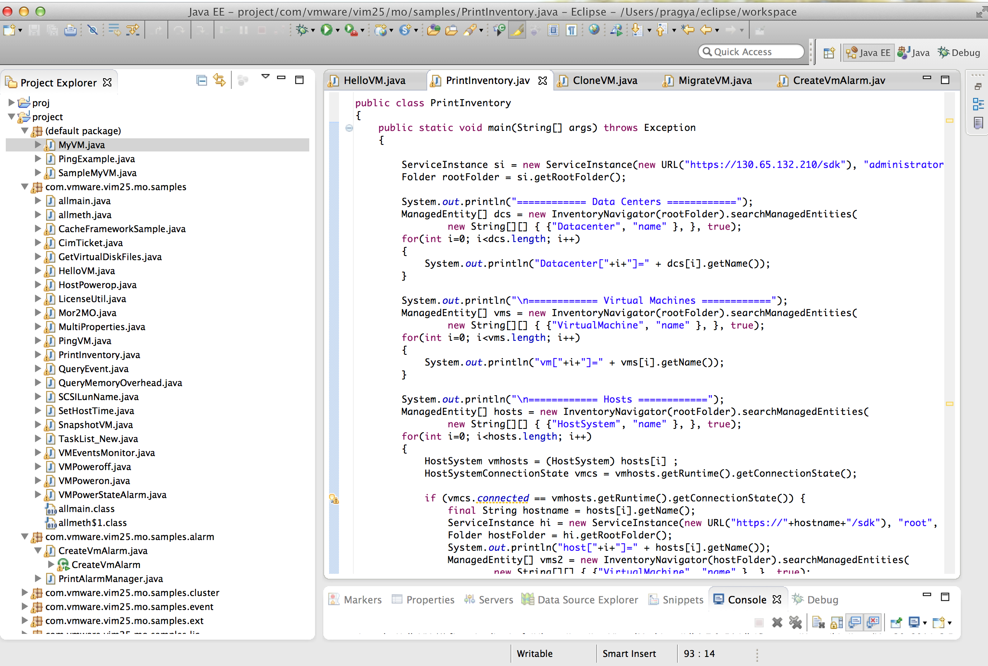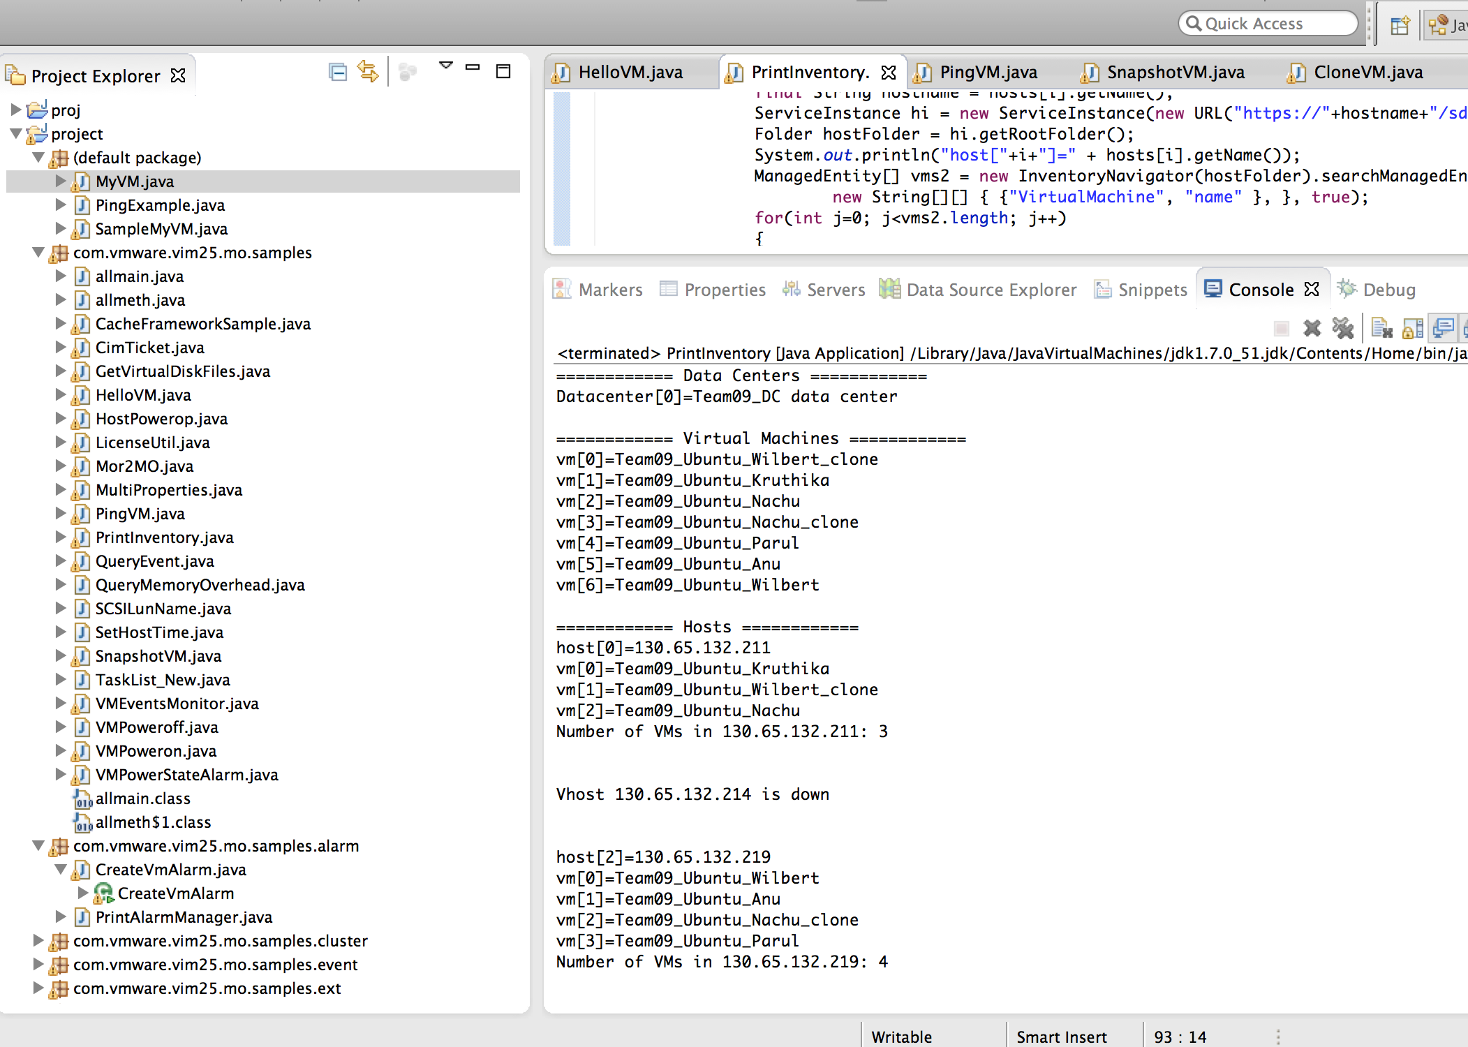lete datacenter inventory

Fig 15: Output for printing the datacenter inventory

Conclusion

This section has the conclusion of the project with lessons learned and challenges faced. This project gave an understanding of how the disaster recovery is performed in real world.

Lessons Learned:

I learnt the following by implementing the project:

* I understood the disaster recovery operation and how it is performed and its functioning.
* I learnt VI Java APIs and it's applications. I also learnt to develop an application using the APIs.
* I understood Snapshot functionality and its use in case of failure.
* I learnt to migrate a VM and make it running at all times even in case of vHost failure.
* I learnt a completely new way of using alarm.

Challenges:

* The most difficult part of the project was to understanding VI Java API and find out which API to use for a particular function.
* Cloning from existing snapshot was a huge challenge.

Future Scope:

The statistics generated can be used to analyze any VM in the datacenter. It can further be expanded by building a real time prevention system for VM failure. In this case, disaster recovery is saved for the worst case scenario when prevention system fails to prevent failure. Whenever new VMs or vHosts are created, the system should take these new VMs and vHosts into consideration and should include them in the scope of monitoring.

Reference

[1] <http://vijava.sourceforge.net/vSphereAPIDoc/ver5/ReferenceGuide/>

[2] <http://www.vmware.com/support/pubs/sdk_pubs.html>

Questions

1. In case of failure, what is a good approach during Disaster Management of Virtual Machines-

o Check the Host first, then the Virtual Machine

o Check the Virtual Machine, then the Host

Justify your answer with sufficient reasons

Answer: In case of Disaster Management of Virtual Machines, the best approach is to check the Host first and then the Virtual Machine. If I check the host first and confirm that the host has failed I need to migrate the virtual machine to another host that is alive. In case the host is reachable and alive, I have narrowed the possibility with respect to searching that is related to the VM and its network.

However, if I check the virtual machine first and I find that it is down, I then need to check the host next to find out the cause of disaster. If the host is also down, I need to migrate the virtual machine to another host that is alive. If the host is alive and the VM has failed, the disaster is due to the VM and its network. This causes redundancy of one extra loop of going between host and VM. Hence, in case of Disaster Management of Virtual Machines, the best approach is to check the Host first and then the Virtual Machine.

2. How many threads do you think are required for the optimal functioning of your Availability Manager? Support your answer with reasons.

Answer: I think 2 threads are required for the optimal functioning of my Availability Manager. I have used two threads - one for regular heartbeat of VMs and other for regular snapshots of VMs. The heart beat is essential to identify that the VM is alive. Thus, we need to obtain the heart beat of all the VMs present in the datacenter at regular intervals. This is achieved by running a java thread. Also, we need to take the snapshot of every VM present in the data center, so that we can recover the VM in case of future failures. So, I ran a thread to take a snapshot of every VM present in the datacenter at regular intervals by using a java thread. This thread deletes the old snapshot and creates a most updated one.

3. How did you set and use the Alarms to aid your Availability Manager? Where else can you use the alarms? Explain

Answer: If a VM is powered off by a user, it would no longer be reachable. This scenario should not be considered as failure. So, to identify such user generated shutdowns, I created an alarm in every VMs in the datacenter. Whenever a new VM is created, a new alarm would be generated in the name of the VM. If the user powers off any VM, the alarm will be triggered. If the alarm is triggered, that particular VM will not be migrated even though its heartbeat would be unreachable. I check the heartbeat of every VM individually at regular intervals. Incase of no response from a VM, I check the alarm triggered action. If no alarm was triggered, I migrated the VM to the first alive vHost in the alive vHost array. If alarm was triggered, no action was taken.

Alarms can also be used to convey an action completion. For example, if I want to know when the updates are getting installed on the VM, I can have an alarm set that would inform me when the updates are installed. In addition on triggering the alarm, I can also perform an operation like suspending the VM after installing updates.